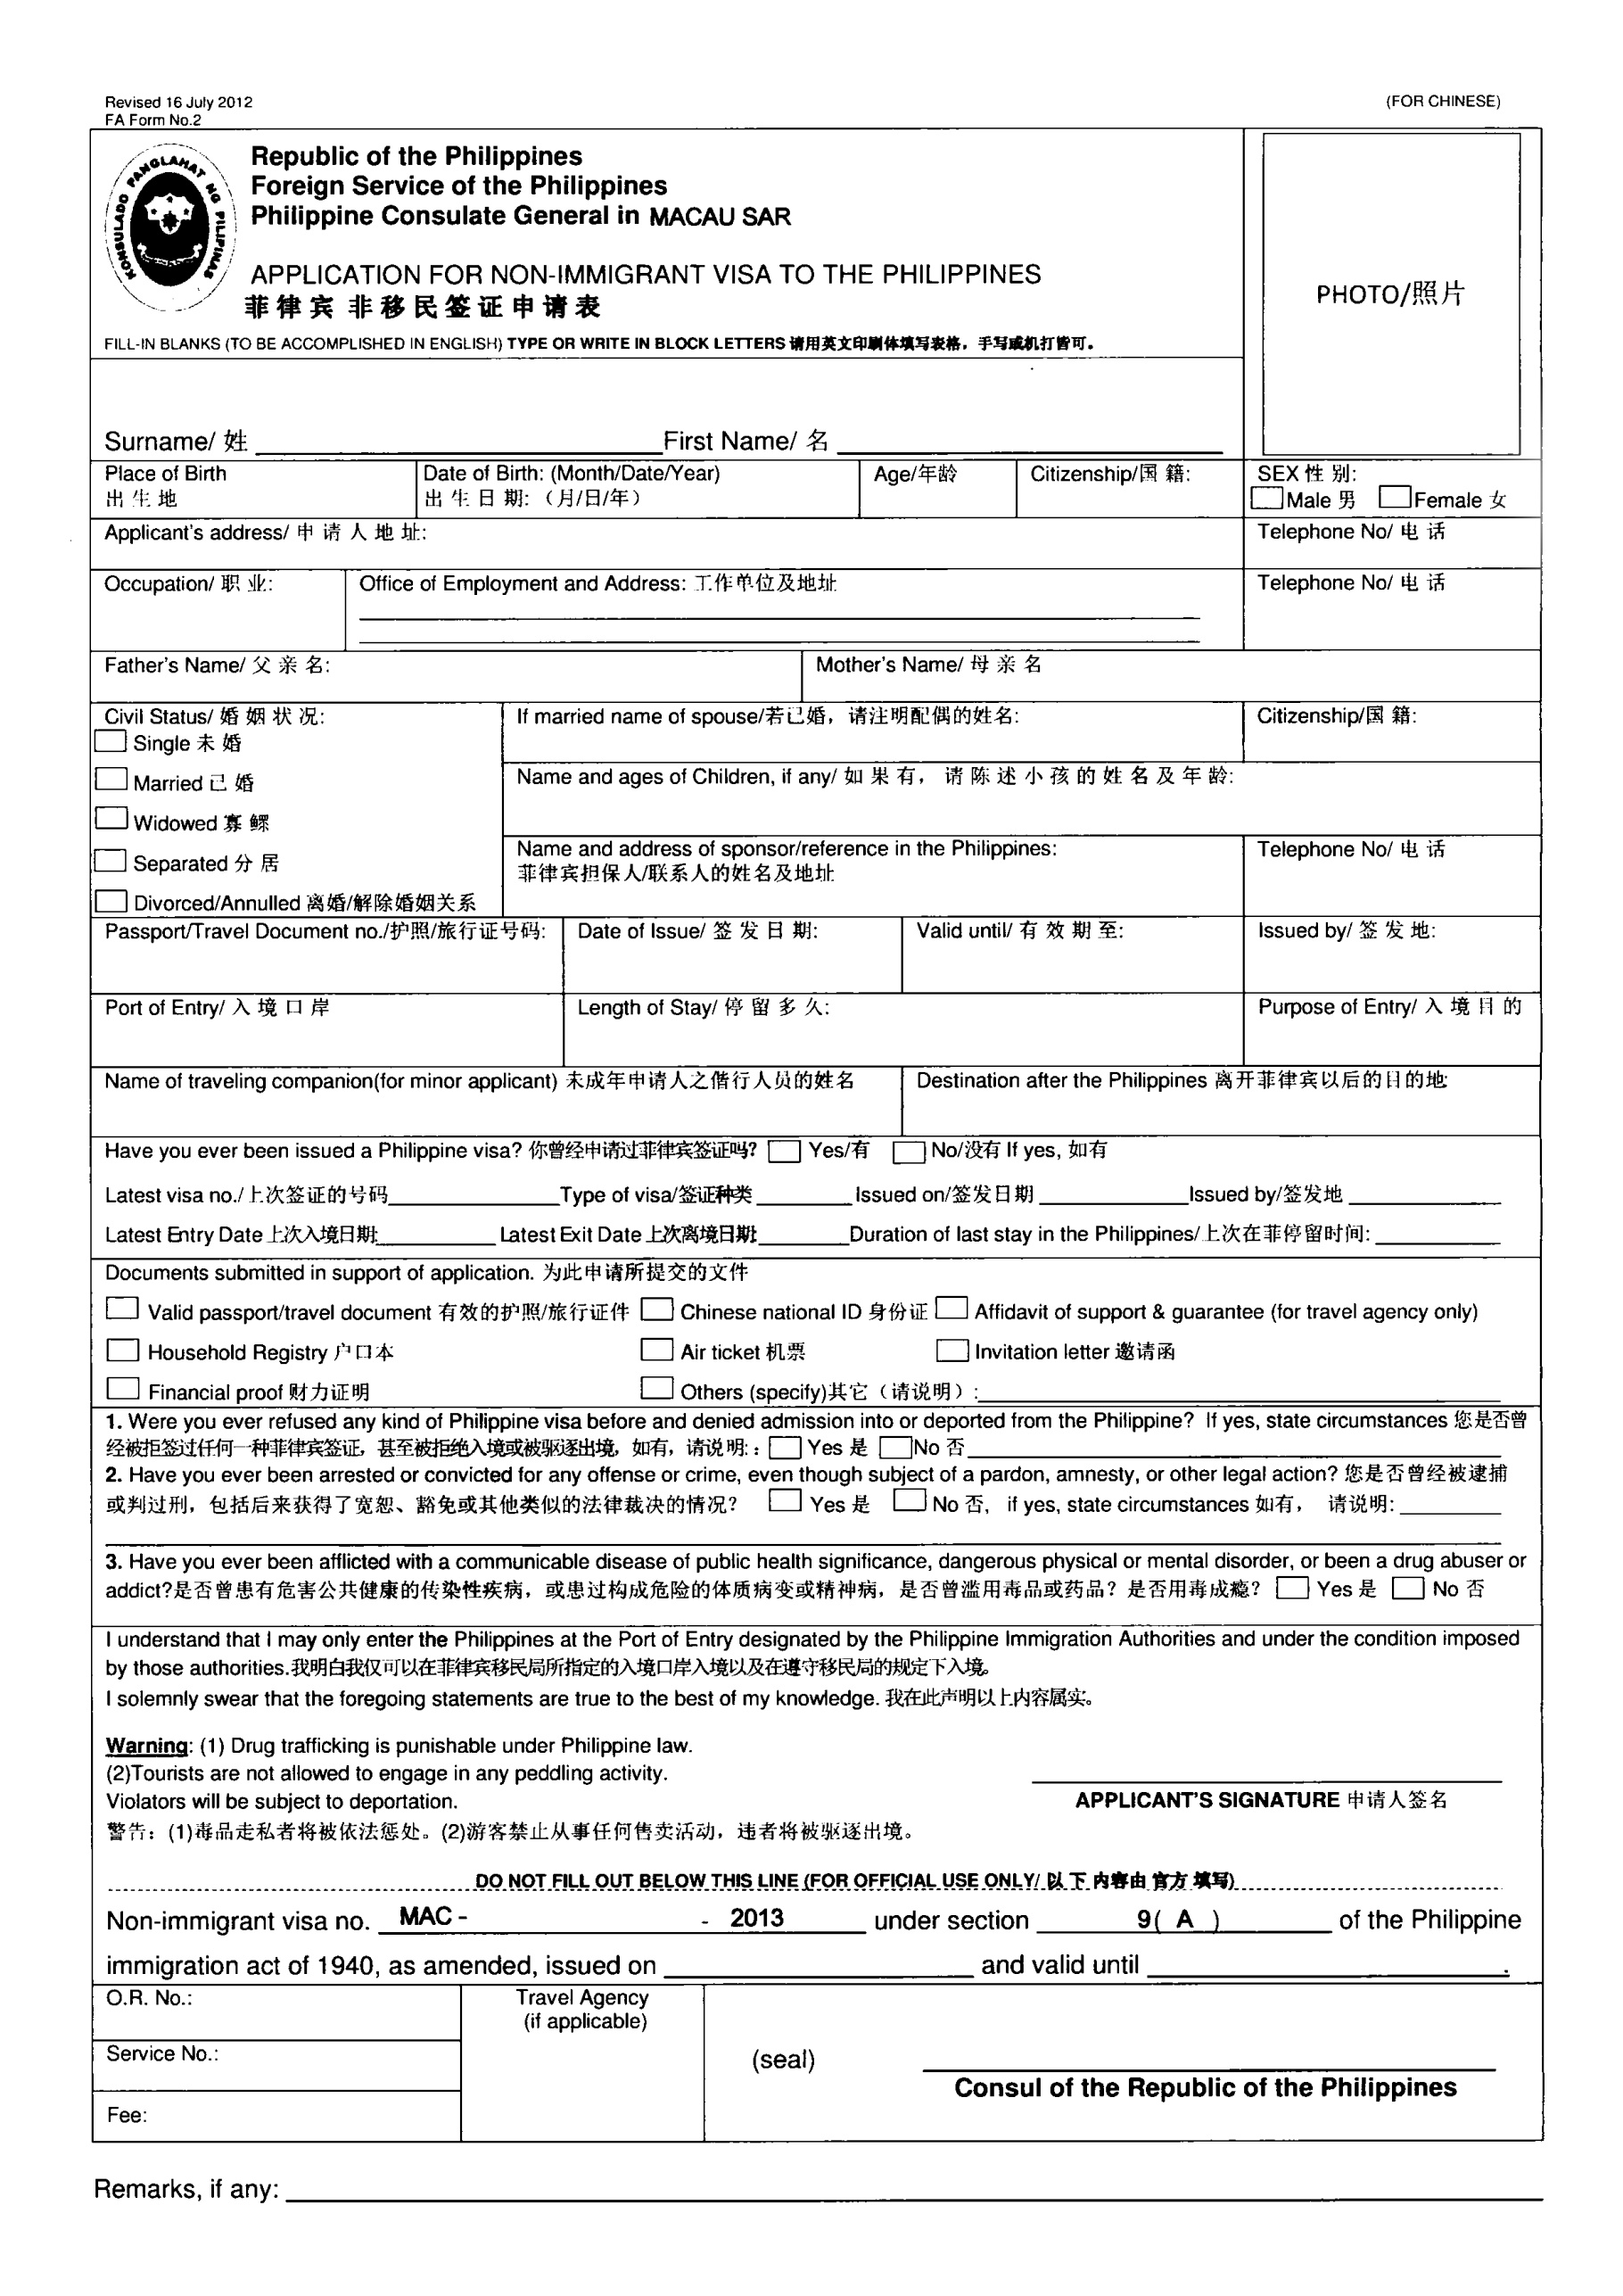
CHE
WENHONG
GUANGDONG
02OCT1954
59
CHINA
Room13801,LITAOGarden3,MaoMing,GUANGDONG,CHINA
Room13801,LITAOGarden3,MaoMing,GUANGDONG,CHINA

CHE YUERONG
XIE BILIAN
LIU LI
LIU LANG 5
CHINA

G39356202
21DEC2009
20DEC2019
GUANGDONG
MANILA
15DAYS
TOURISM
13318512833

13318512833

/

1

√
√
√
√
√
√
√
√

√

